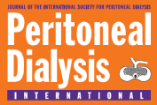

Date: 29 July 2026

Dear Peritoneal Dialysis International Contributor:

Please find enclosed the edited galleys of your article that is to be published in an upcoming issue of Peritoneal Dialysis International.

Please note the following:

- Please proof all text, headings, footnotes, references, captions, etc., and mark clearly any changes to be made. It is the author’s responsibility to compare the edited galleys with the original manuscript in order to ensure the highest degree of accuracy in the representation of your thesis.
- Please answer any of the editors’ questions (noted as “Author Queries” on the last page of the article) in full. Should you have any questions, please contact Multimed Inc. immediately.
- All references have been edited (if necessary) to comply with the International “Vancouver” style.
- All reference abbreviations have been edited to comply with the List of Serials Indexed (2008) (U.S.) National Library of Medicine ISSN 0736-7139.
- We will correct up to 10% of the completed pages at no charge. Any changes exceeding 10% will be charged back to the author at a flat fee of $100.00 (U.S.), payable to MULTIMED INC. This amount must be received prior to final authorization to publish you article.
- Please sign the following waiver on completion of review and e-mail it back to Multimed Inc.

I, Nicole Scholes-Robertson , have reviewed the article entitled
(print name clearly)
“The Norm Bourke Box: A Patient-Led Initiative to Improve Care for Rural Patients Requiring Peritoneal Dialysis” and acknowledge it to be in good order (subject to those changes indicated). I therefore assign the rights to Multimed Inc. to proceed to publish this final and approved article in print and in all media now and hereafter known, including electronic media and the Internet.

DATE 08/05/2019 SIGNATURE ______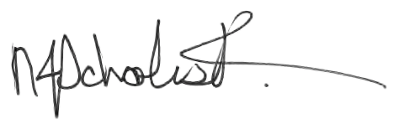
__________________________

THIS FORM IS DUE:
PLEASE CONTACT US IMMEDIATELY

IF YOU CANNOT MEET THE DEADLINE.
Publisher:
Multimed Inc.
66 Martin Street
Milton, Ontario
CANADA L9T 2R2
Tel: 905-875-2456
Fax: 905-875-2864

Email: heather_shand@multi-med.com

